- Network Topology Report

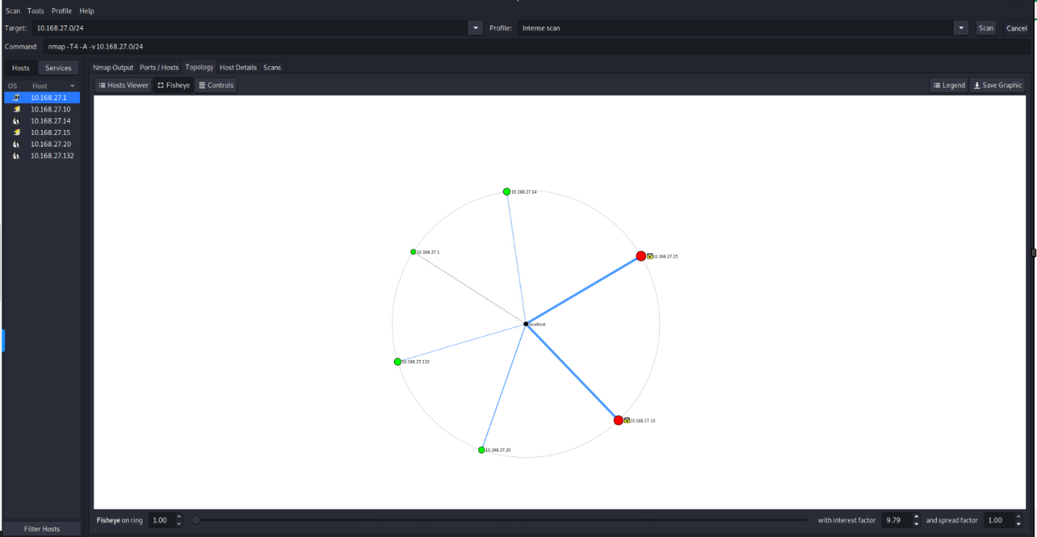
The network topology scan covers a subnet in the IP range of 10.168.27.0/24. The IP addresses in this range fall under the Class A category, which is typically used for large networks. Here is the detailed report for each scanned host:

Hosts and Operating Systems:
- 10.168.27.1
  - OS: Linux 2.6.X
  - Services: SSH, running on a general-purpose device

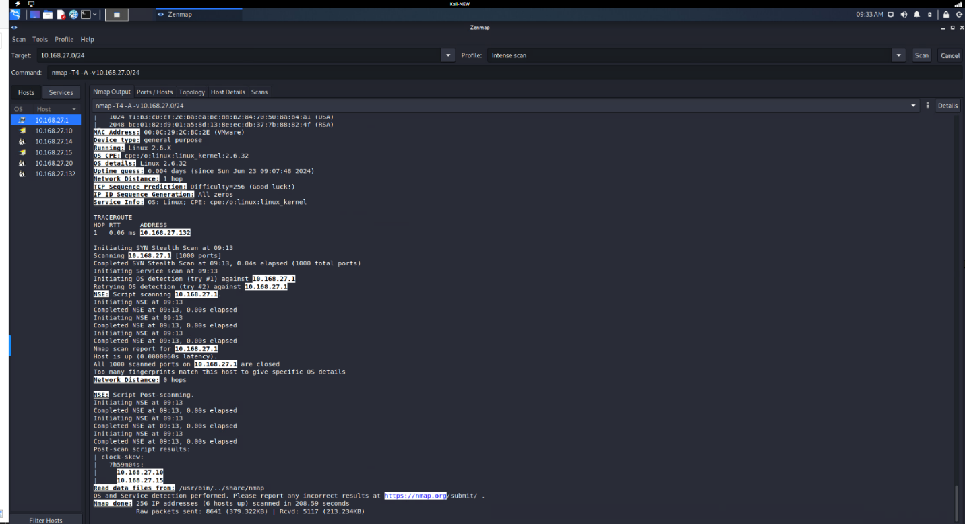
- 10.168.27.10
  - OS: Microsoft Windows Server 2012 R2
  - Services: RPC, SMB, Microsoft DS, NetBIOS
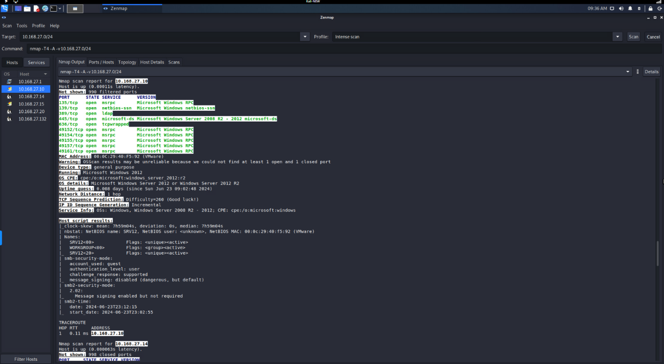
- 10.168.27.14
  - OS: Microsoft Windows 8.1
  - Services: HTTP, NetBIOS, Microsoft DS, FTP, FileZilla
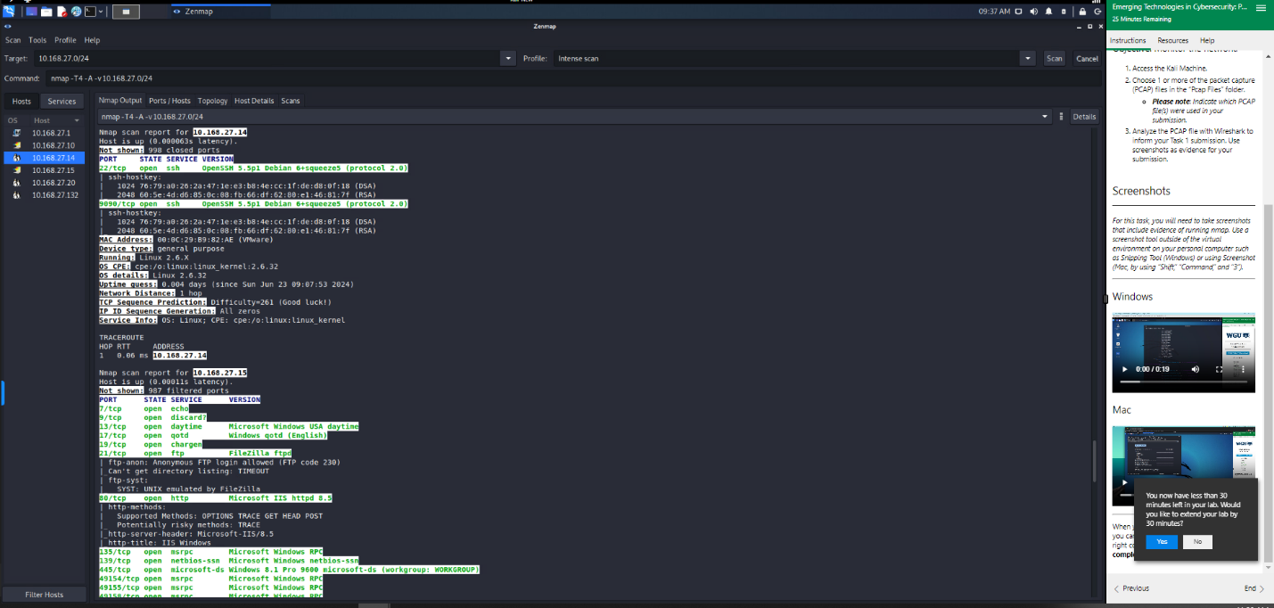
- 10.168.27.15
  - OS: Microsoft Windows 8.1
  - Services: HTTP, NetBIOS, Microsoft DS, FTP, FileZilla
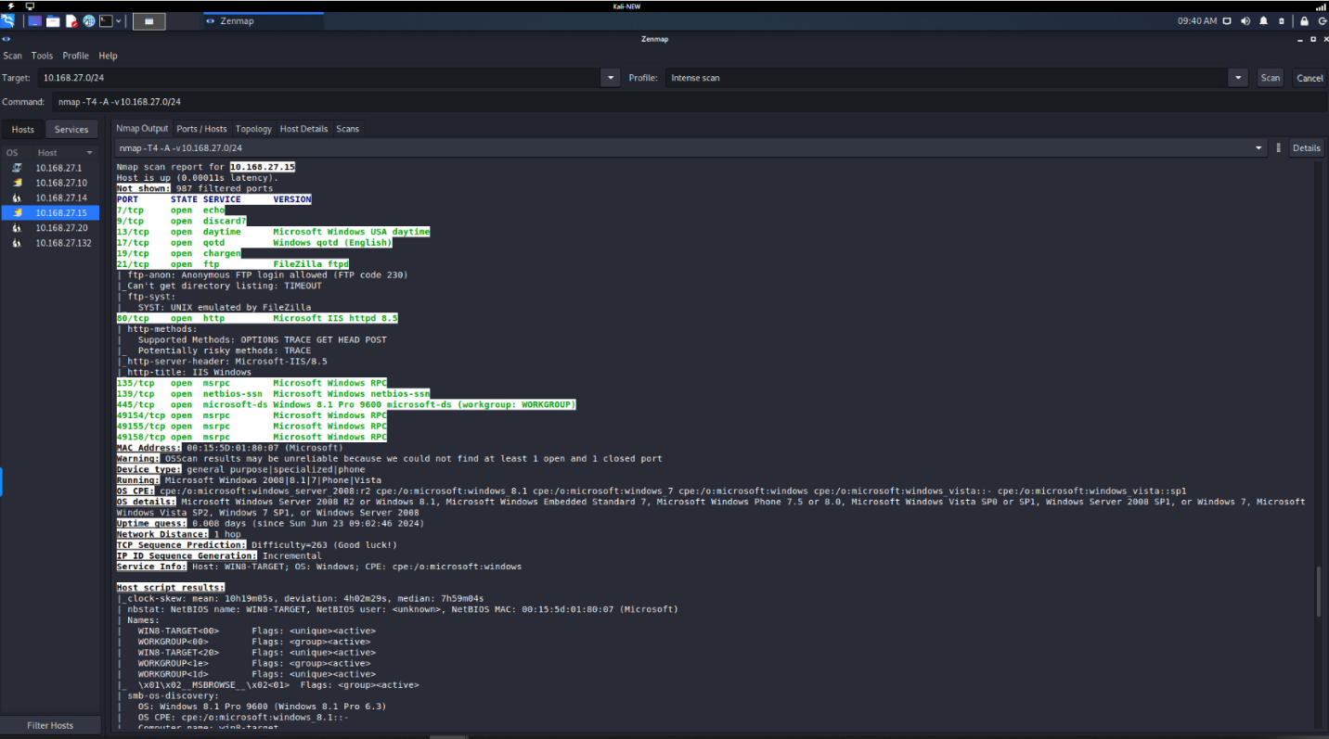
- 10.168.27.20
  - OS: Linux 2.6.X
  - Services: OpenSSH 5.5p1
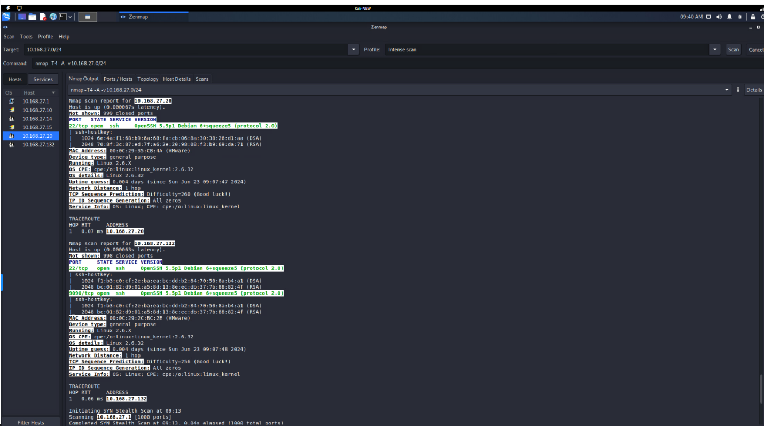
- 10.168.27.132
  - OS: Linux 2.6.X
  - Services: OpenSSH 5.5p1
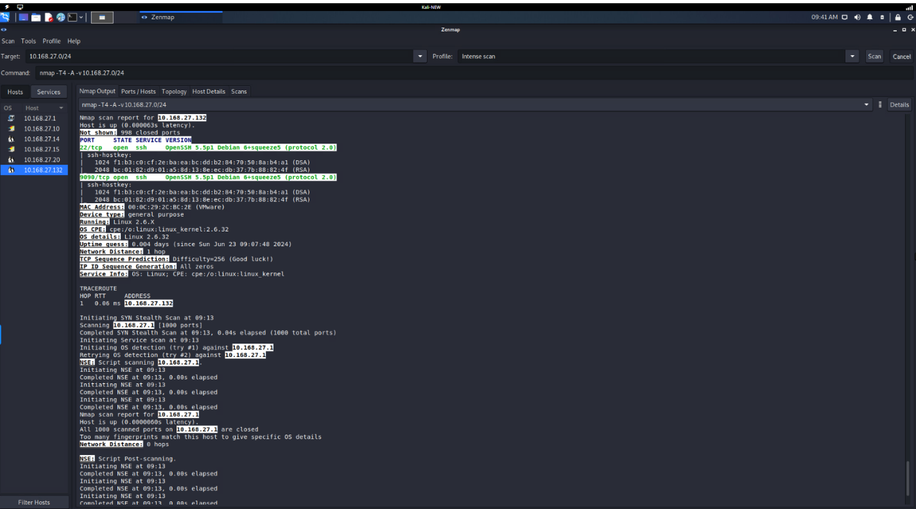

- Vulnerabilities and Implications:

Vulnerabilities and Implications:
- 10.168.27.1
  - Vulnerabilities: The system has SSH open, which if improperly configured or using weak credentials, could be vulnerable to brute force attacks. This might include vulnerabilities like CVE-2018-15473.
  - Implications: Unauthorized access to the system, potential data breach, or use as a pivot point for further attacks.

- 10.168.27.10
  - Vulnerabilities: Multiple services including RPC, SMB, Microsoft DS, and NetBIOS are open. These are known to be vectors for exploits such as EternalBlue (CVE-2017-0144) and SMB vulnerabilities (CVE-2017-0145).
  - Implications: Potential remote code execution, spreading of malware, and unauthorized access to shared resources.

- 10.168.27.14 and 10.168.27.15
  - Vulnerabilities: HTTP service running Microsoft IIS 8.5 with potential exposure to web-based vulnerabilities like CVE-2015-1635. FTP service running FileZilla might allow anonymous login, leading to unauthorized file access (CVE-2019-5420).
  - Implications: Website defacement, unauthorized file access, data theft, and server compromise.

- 10.168.27.20 and 10.168.27.132
  - Vulnerabilities: OpenSSH 5.5p1 is quite outdated and may have multiple known vulnerabilities, including issues that could allow remote code execution such as CVE-2016-10009 and CVE-2016-10012.
  - Implications: Compromise of the SSH service could lead to full control over the system, data exfiltration, and further attacks on the network.

Conclusion:
The network scan reveals several potential vulnerabilities across different hosts, with critical services exposed that could be exploited if not properly secured. Immediate actions should include updating outdated software, securing SSH access, disabling unnecessary services, and implementing strong authentication mechanisms to mitigate risks.
- Anomalies Detected in Network Packets

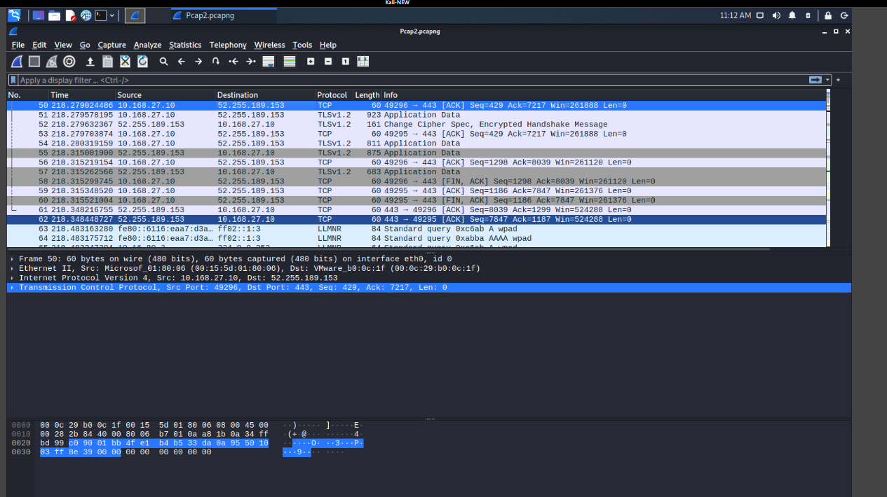

Anomaly 1: Unusually Short Packets
- Range of Packets: Packets 50, 52, and 54
- Description: These packets have a length of 60 bytes, which is unusually short for TCP packets. This often indicates a TCP SYN or ACK scan used for network reconnaissance.

Anomaly 2: TCP Reset (RST) Flag
- Range of Packets: Packet 56
- Description: This packet has the RST (Reset) flag set. Anomalous RST flags can suggest attempts to disrupt ongoing connections, potentially pointing to Denial-of-Service (DoS) attacks or session hijacking attempts.

Anomaly 3: TLS Handshake Irregularities
- Range of Packets: Packets 53, 55, 57, 59
- Description: Several packets indicate TLS version 1.2 handshake and encrypted data transfer. While encrypted traffic is generally secure, irregularities in these handshake patterns can suggest potential MitM (Man-in-the-Middle) attacks or issues with TLS configuration.

- Implications of Each Anomaly
- Unusually Short Packets
  - Implication: Short packets, especially in the context of TCP, can indicate scanning activity, which is often a precursor to more intrusive attacks. These can be used to map out network topology and identify open ports.
  - Source: CVE-2004-0230 - TCP sequence number approximation vulnerability that can lead to a denial of service.
- TCP Reset (RST) Flag
  - Implication: The presence of unexpected RST flags can indicate attempts to disrupt legitimate connections, potentially leading to denial of service for affected applications. This can be a tactic used by attackers to interrupt services or manipulate session states.
  - Source: CVE-2013-6282 - Vulnerability in TCP RST handling which can lead to a DoS attack.
- TLS Handshake Irregularities
  - Implication: Irregularities in TLS handshake patterns could suggest an attempted MitM attack or misconfiguration in the TLS setup, which can compromise the security of data in transit.
  - Source: CVE-2016-0800 - A vulnerability in SSLv2 that allows decryption of TLS connections (DROWN attack).
- Resolution for Each Anomaly
- Unusually Short Packets
  - Resolution: Implement network security measures to detect and block scanning activity. Tools such as firewalls and intrusion detection/prevention systems (IDS/IPS) can help mitigate these threats. Regularly review and update network security policies to ensure they are effective against reconnaissance activities.
  - Source: NIST SP 800-94 - Guide to Intrusion Detection and Prevention Systems.
- TCP Reset (RST) Flag
  - Resolution: Analyze the source and pattern of RST flags to determine their legitimacy. Use network security tools to detect and block malicious RST packets. Implement network traffic analysis to identify and respond to potential DoS attacks or session hijacking attempts.
  - Source: NIST SP 800-189 - Resilient Interdomain Traffic Exchange: BGP Security and DDoS Mitigation.
- TLS Handshake Irregularities
  - Resolution: Ensure that TLS configurations are up to date and follow best practices. Regularly audit TLS implementations to check for vulnerabilities and misconfigurations. Employ tools to monitor for unusual patterns in encrypted traffic that may indicate security issues.
  - Source: NIST SP 800-52 Rev. 2 - Guidelines for the Selection, Configuration, and Use of Transport Layer Security (TLS) Implementations.

- References
- CVE-2004-0230 - TCP sequence number approximation vulnerability that can lead to a denial of service.
  - MITRE. (2004). CVE-2004-0230. Retrieved from https://cve.mitre.org/cgi-bin/cvename.cgi?name=CVE-2004-0230
- CVE-2013-6282 - Vulnerability in TCP RST handling which can lead to a DoS attack.
  - MITRE. (2013). CVE-2013-6282. Retrieved from https://cve.mitre.org/cgi-bin/cvename.cgi?name=CVE-2013-6282
- CVE-2016-0800 - A vulnerability in SSLv2 that allows decryption of TLS connections (DROWN attack).
  - MITRE. (2016). CVE-2016-0800. Retrieved from https://cve.mitre.org/cgi-bin/cvename.cgi?name=CVE-2016-0800
- NIST SP 800-94 - Guide to Intrusion Detection and Prevention Systems.
  - Scarfone, K., & Mell, P. (2007). Guide to Intrusion Detection and Prevention Systems (IDPS). National Institute of Standards and Technology. Retrieved from https://nvlpubs.nist.gov/nistpubs/Legacy/SP/nistspecialpublication800-94.pdf
- NIST SP 800-189 - Resilient Interdomain Traffic Exchange: BGP Security and DDoS Mitigation.
  - Kuhn, D. R., Rossman, H., & Vassilev, A. (2019). Resilient Interdomain Traffic Exchange: BGP Security and DDoS Mitigation. National Institute of Standards and Technology. Retrieved from https://csrc.nist.gov/publications/detail/sp/800-189/final
- NIST SP 800-52 Rev. 2 - Guidelines for the Selection, Configuration, and Use of Transport Layer Security (TLS) Implementations.
  - Barker, E., Souppaya, M., & Orebaugh, A. (2019). Guidelines for the Selection, Configuration, and Use of Transport Layer Security (TLS) Implementations. National Institute of Standards and Technology. Retrieved from https://nvlpubs.nist.gov/nistpubs/SpecialPublications/NIST.SP.800-52r2.pdf

